|  |  |  |  |
| --- | --- | --- | --- |
| **Name of Student: NINAD AVINASH PATIL** | | | |
| **Roll No: 33** | | **Lab Practical Number: 4(B)** | |
| **Title of Lab Practical: Create a webpage using Advanced web server controls (Data source control, Data View control, Personalization controls, Login and security control, Navigation controls, Rich controls).** | | | |
| **DOP: 06/04/2021** | | **DOS: 13/04/2021** | |
| **CO Mapped: CO1** | **PO Mapped: PO3, PO5, PO7,**  **PO12, PSO1, PSO2** | **Faculty Signature:** | **Marks:** |

**Practical No 4(B)**

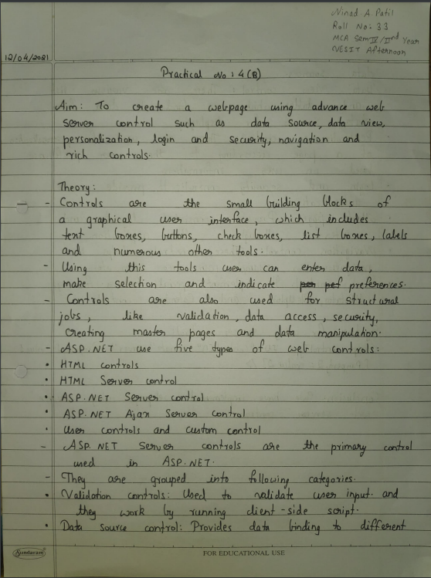

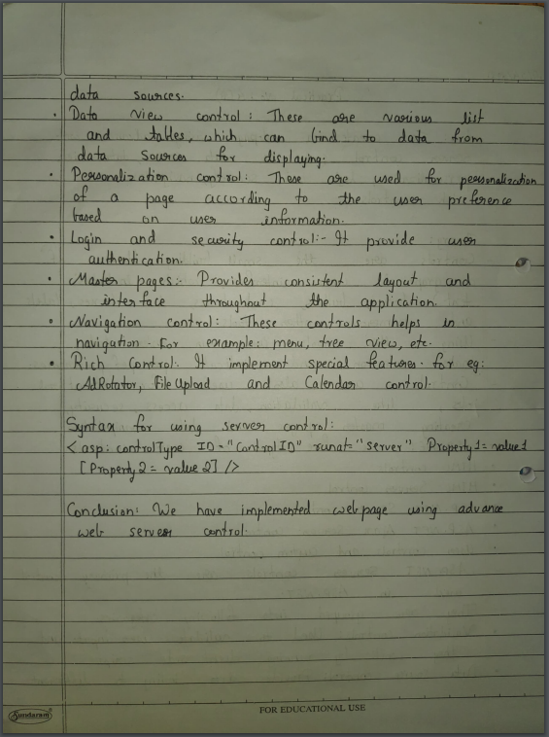

**Code:**

**WebForm1.aspx**

<%@ Page Language="C#" AutoEventWireup="true" CodeBehind="WebForm1.aspx.cs" Inherits="WebApplication1.WebForm1" %>

<!DOCTYPE html PUBLIC "-//W3C//DTD XHTML 1.0 Transitional//EN" "http://www.w3.org/TR/xhtml1/DTD/xhtml1-transitional.dtd">

<html xmlns="http://www.w3.org/1999/xhtml">

<head runat="server">

<title>Advanced Web Server Controls</title>

</head>

<body>

<form id="form1" runat="server">

<h3>Navigation Control Page</h3>

<div>

<asp:TreeView ID="TreeView1" runat="server"

onselectednodechanged="TreeView1_SelectedNodeChanged" ShowLines="True">

<Nodes>

<asp:TreeNode Expanded="False" SelectAction="Expand" Text="Actions"

Value="Actions">

<asp:TreeNode NavigateUrl="~/WebForm2.aspx" Text="Login" Value="Login">

</asp:TreeNode>

<asp:TreeNode NavigateUrl="~/WebForm3.aspx" Text="Personalization" Value="Personalization">

</asp:TreeNode>

<asp:TreeNode NavigateUrl="~/WebForm4.aspx" Text="Rich Control" Value="Rich Control">

</asp:TreeNode>

<asp:TreeNode NavigateUrl="~/WebForm5.aspx" Text="Data View & Data Source"

Value="Data View & Data Source">

</asp:TreeNode>

</asp:TreeNode>

</Nodes>

</asp:TreeView>

<br /> </div> </form>

</body>

</html>

**WebForm2.aspx**

<%@ Page Language="C#" AutoEventWireup="true" CodeBehind="WebForm2.aspx.cs" Inherits="WebApplication1.WebForm2" %>

<!DOCTYPE html PUBLIC "-//W3C//DTD XHTML 1.0 Transitional//EN" "http://www.w3.org/TR/xhtml1/DTD/xhtml1-transitional.dtd">

<html xmlns="http://www.w3.org/1999/xhtml">

<head runat="server">

<title>Advanced Web Server Controls</title>

</head>

<body>

<form id="form1" runat="server">

<h3>Login and Security Control Page</h3>

<div>

<asp:Login ID="Login1" runat="server" onauthenticate="Login1_Authenticate"

BackColor="#F7F6F3" BorderColor="#E6E2D8" BorderPadding="4" BorderStyle="Solid"

BorderWidth="1px" FailureText="" Font-Names="Verdana" Font-Size="0.8em"

ForeColor="#333333" Height="122px" RememberMeText="Remember Me" Width="332px">

<InstructionTextStyle Font-Italic="True" ForeColor="Black" />

<LoginButtonStyle BackColor="#FFFBFF" BorderColor="#CCCCCC" BorderStyle="Solid"

BorderWidth="1px" Font-Names="Verdana" Font-Size="0.8em" ForeColor="#284775" />

<TextBoxStyle Font-Size="0.8em" />

<TitleTextStyle BackColor="#5D7B9D" Font-Bold="True" Font-Size="0.9em"

ForeColor="White" />

</asp:Login>

<br />

<br />

<asp:Label ID="Label1" runat="server" Text="Show result"></asp:Label>

</div>

</form>

</body>

</html>

**WebForm3.aspx**

<%@ Page Language="C#" AutoEventWireup="true" CodeBehind="WebForm3.aspx.cs" Inherits="WebApplication1.WebForm3" %>

<!DOCTYPE html PUBLIC "-//W3C//DTD XHTML 1.0 Transitional//EN" "http://www.w3.org/TR/xhtml1/DTD/xhtml1-transitional.dtd">

<script runat="server">

void Page_Load(object sender, EventArgs e)

{

Profile.UserCount += 1;

}

void btnGetProfileValues_Click(object sender, EventArgs e)

{

lblName.Text = Profile.Name;

lblUserCount.Text = Profile.UserCount.ToString();

}

void btnSetName_Click(object sender, EventArgs e)

{

Profile.Name = txtName.Text;

}

</script>

<html xmlns="http://www.w3.org/1999/xhtml">

<head runat="server">

<title>Advanced Web Server Controls</title>

</head>

<body>

<form id="form1" runat="server">

<h3>Personalization Control Page</h3>

<div>

Name : <asp:TextBox runat="server" ID="txtName" />

<asp:Button runat="server" ID="btnSetName"

Text="Set Name" OnClick="btnSetName_Click" /><br />

<br/><br/>

<asp:Button runat="server" ID="btnGetProfileValues"

Text="Get Profile Values"

OnClick="btnGetProfileValues_Click" />

<br/> <br />

Profile Values: <br /><br />

UserName: <asp:Label runat="server" ID="lblName"/>

<br/>

UserCount: <asp:Label runat="server" ID="lblUserCount"/>

</div>

</form>

</body>

</html>

**WebForm4.aspx**

<%@ Page Language="C#" AutoEventWireup="true" CodeBehind="WebForm4.aspx.cs" Inherits="WebApplication1.WebForm4" %>

<!DOCTYPE html PUBLIC "-//W3C//DTD XHTML 1.0 Transitional//EN" "http://www.w3.org/TR/xhtml1/DTD/xhtml1-transitional.dtd">

<html xmlns="http://www.w3.org/1999/xhtml">

<head runat="server">

<title>Advanced Web Server Controls</title>

</head>

<body>

<h3>Rich Control Page</h3>

<form id="form1" runat="server">

<div>

<asp:Calendar ID="Calendar1" runat="server"

onselectionchanged="Calendar1_SelectionChanged"></asp:Calendar><br />

<asp:Label ID="Label1" runat="server" Text="Label"></asp:Label>

</div>

</form>

</body>

</html>

**WebForm5.aspx**

<%@ Page Language="C#" AutoEventWireup="true" CodeBehind="WebForm5.aspx.cs" Inherits="WebApplication1.WebForm5" %>

<!DOCTYPE html PUBLIC "-//W3C//DTD XHTML 1.0 Transitional//EN" "http://www.w3.org/TR/xhtml1/DTD/xhtml1-transitional.dtd">

<html xmlns="http://www.w3.org/1999/xhtml">

<head runat="server">

<title>Advanced Web Server Controls</title>

</head>

<body>

<h3>Data View & Data Source Control Page</h3>

<form id="form1" runat="server">

<div>

<asp:GridView ID="GridView1" runat="server" AutoGenerateColumns="False"

DataSourceID="SqlDataSource1">

<Columns>

<asp:BoundField DataField="Roll No" HeaderText="Roll No" SortExpression="Roll No" />

<asp:BoundField DataField="Name" HeaderText="Name" SortExpression="Name" />

<asp:BoundField DataField="Programme" HeaderText="Programme" SortExpression="Programme" />

<asp:BoundField DataField="Course" HeaderText="Course" SortExpression="Course" />

</Columns>

</asp:GridView>

<asp:SqlDataSource ID="SqlDataSource1" runat="server" ConnectionString="<%$ ConnectionStrings:StudentConnectionString %>" SelectCommand="SELECT * FROM [MCA]"></asp:SqlDataSource>

</div>

</form>

</body>

</html>

**Output:**

**Navigation controls**

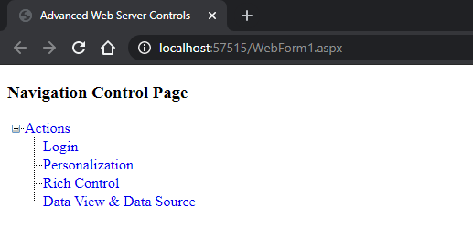

**Login and security control**

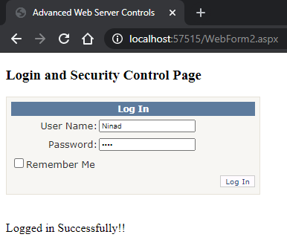

**Personalization controls**

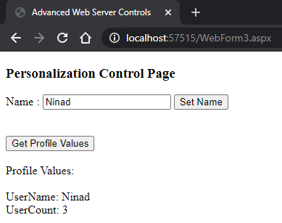

**Rich controls**

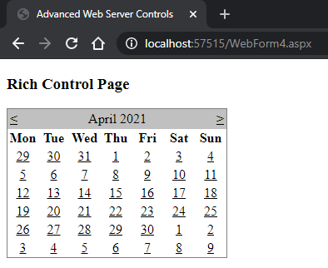

**Data source control & Data View control**

